**Practice Patters**

Q. 1

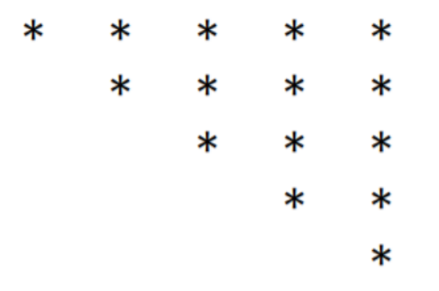

Q.2

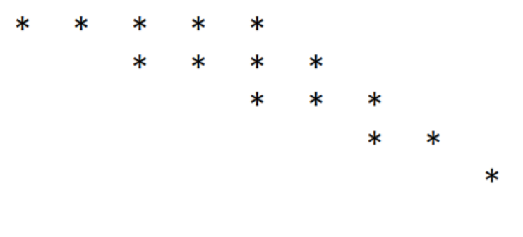

Q.3

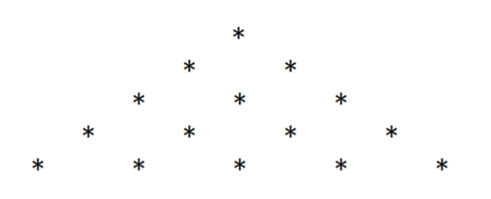

Q.4

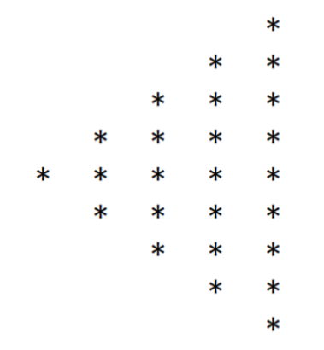

Q.5

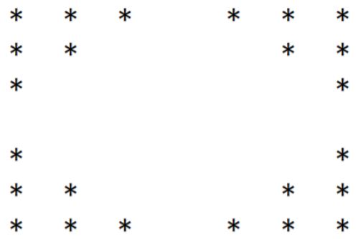

Q.6

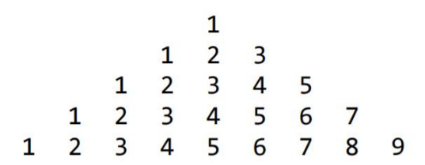

Q.7

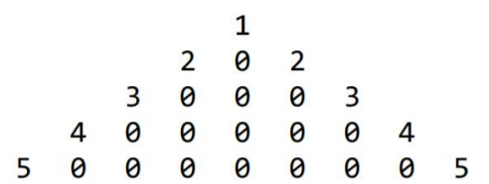

Q.8

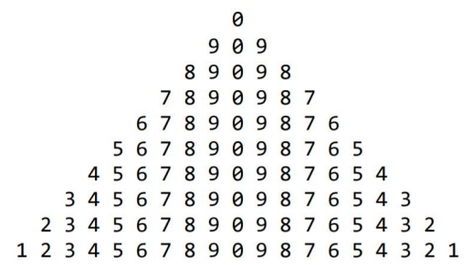

Q.9

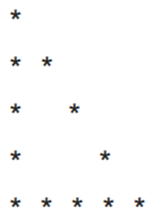

Q.10

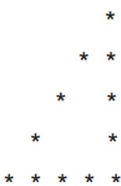

Q.11

1

1 1

1 2 1

1 3 3 1

1 4 6 4 1

1 5 10 10 5 1

Q.12

*

* * *

* * * * *

* * * * * * *

* * * * *

* * *

*